The Domesticated Mess – Valentine’s Day Taco Printable

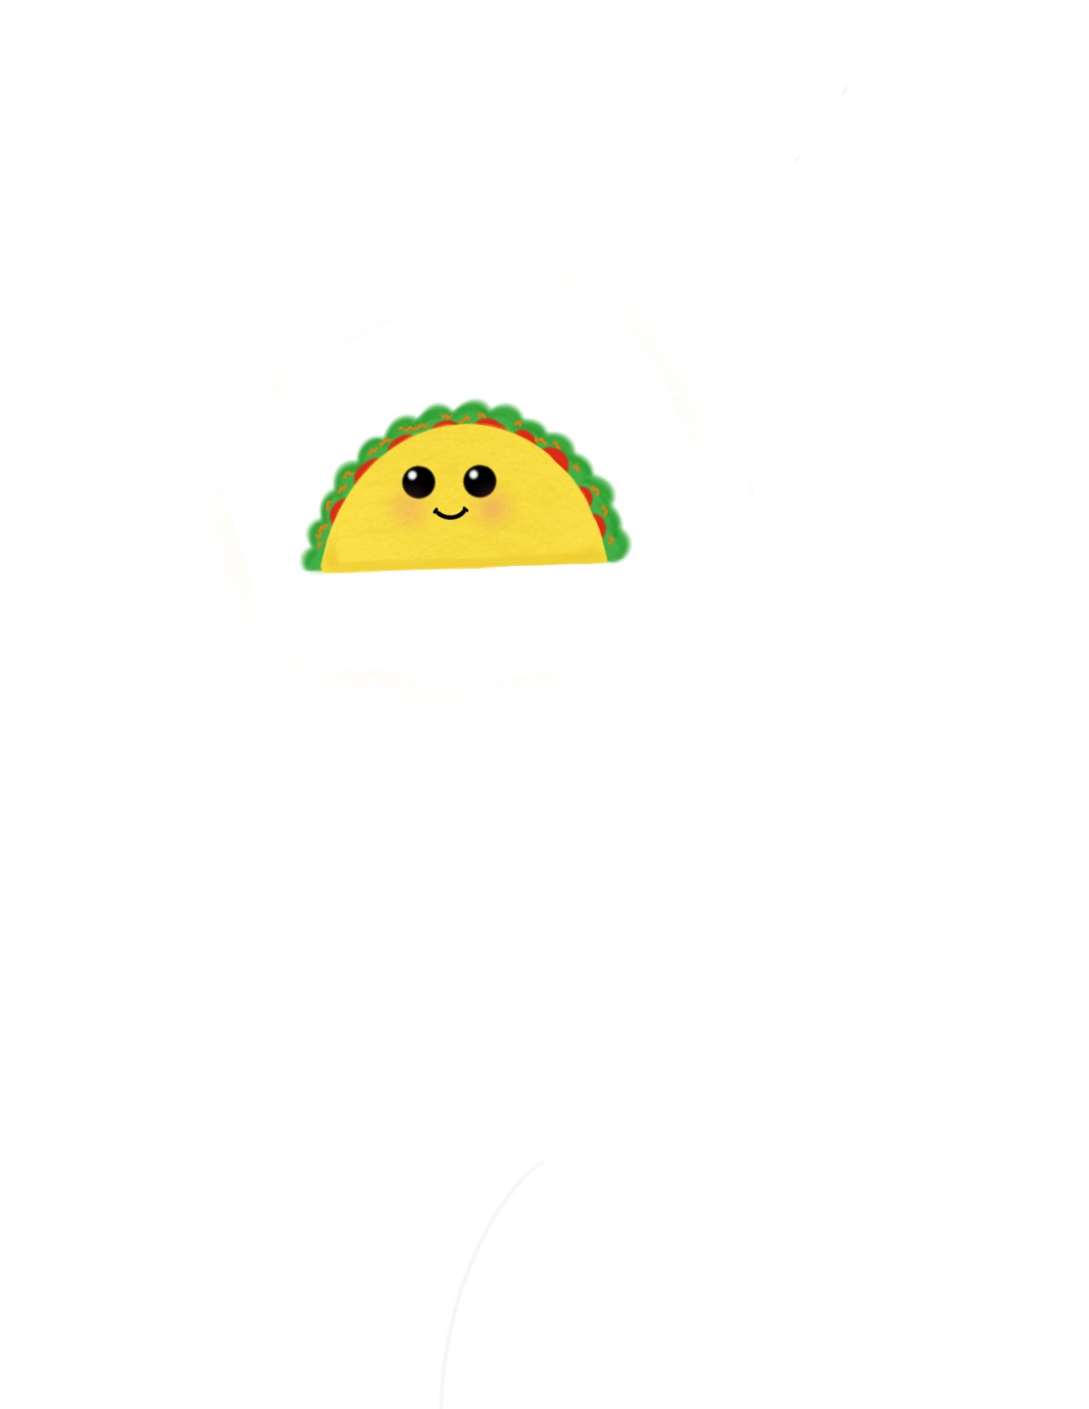

Taco ‘bout a great Friend!

Taco ‘bout a great Friend!

Taco ‘bout a great Friend!

Taco ‘bout a great Friend!

Taco ‘bout a great Friend!

Taco ‘bout a great Friend!

Taco ‘bout a great Friend!

Taco ‘bout a great Friend!

From: Stephanie

From: Stephanie

From: Stephanie

From: Stephanie

From: Stephanie

From: Stephanie

From: Stephanie

From: Stephanie