The Domesticated Mess – Valentine’s Day Loads of Fun Printable

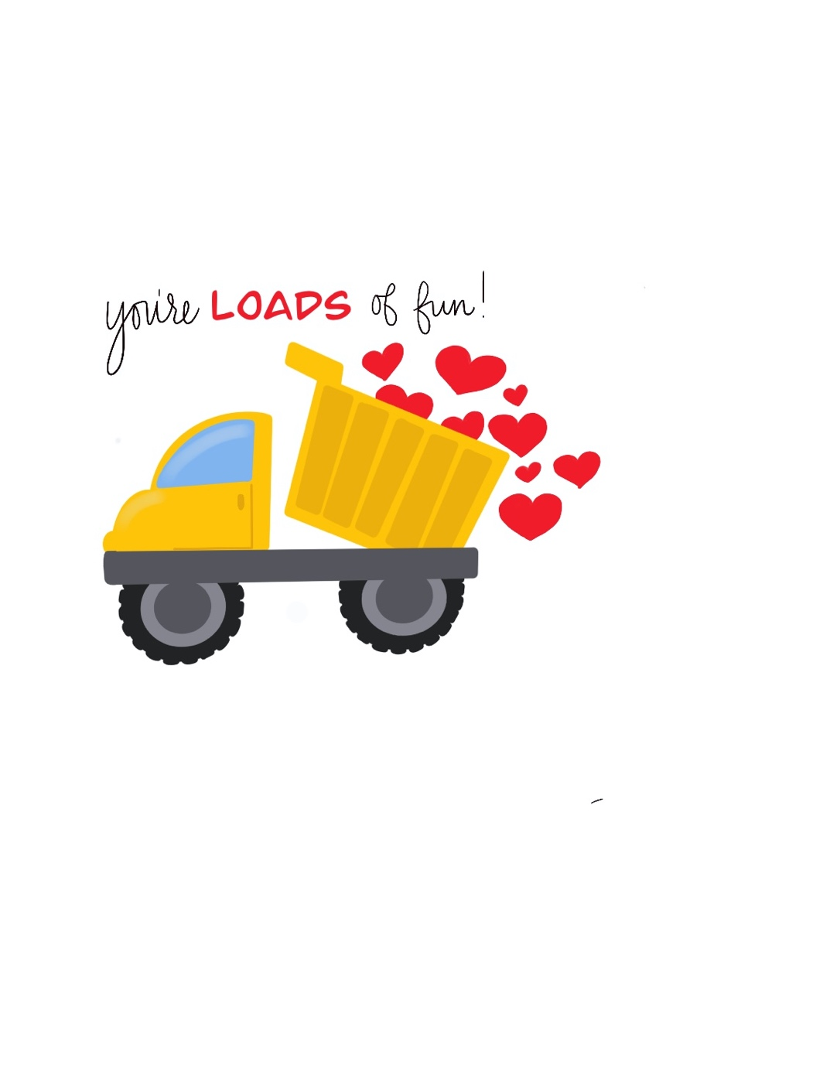

From: Stephanie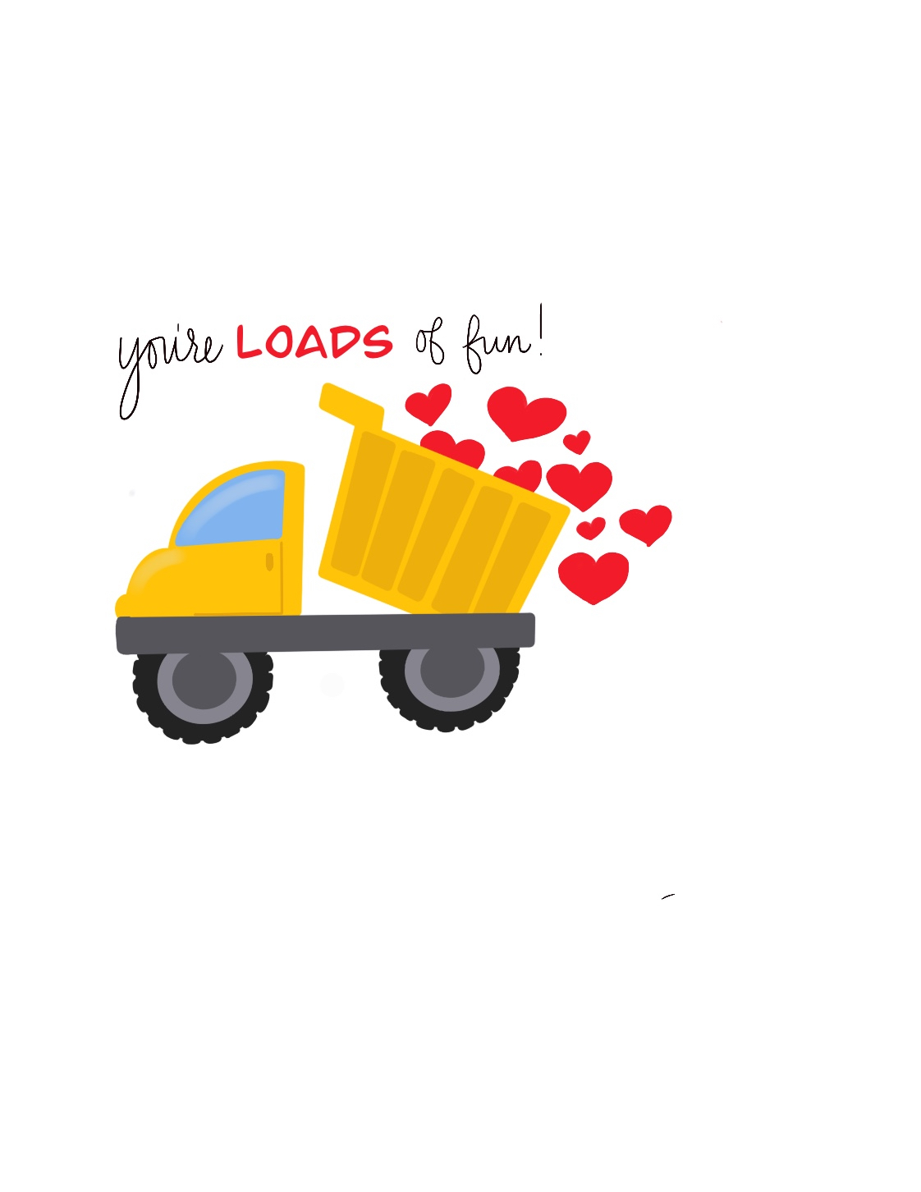ie

From: Stephanieie

From: Stephanieie

From: Stephanieie

From: Stephanie

From: Stephanieie